**Databel Customer Churn Analysis**

**Abstract**

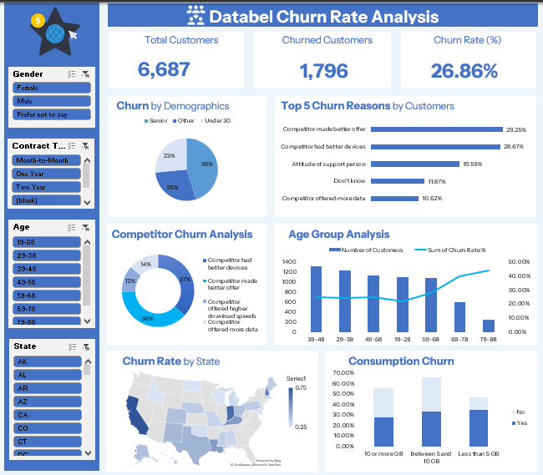

**INTRODUCTION**

This project analyzes customer churn at Databel, focusing on identifying the key drivers behind customer departures. By understanding churn patterns across states, demographics, and service usage, this analysis enables stakeholders to implement targeted strategies that improve customer retention and reduce churn-related losses.

**Problem Statement**

Databel appears to be experiencing a significant challenge with customer attrition this suggests a potential loss of customers that could negatively impact revenue, market share, and overall business growth. This analysis focus on various customer attributes like demographics, contract types, age groups, and consumption patterns implies that the drivers of this churn are likely complex and multifaceted, requiring detailed investigation to understand the underlying causes and develop effective retention strategies.

**Objectives**

* Determine the overall customer churn rate
* Identify states and customer segments with high churn
* Understand the main reasons for customer departure
* Analyze how age and data consumption relate to churn
* Provide actionable insights for reducing

**Potential Questions**

* Which demographic segment (Senior, Other, or Under 30) accounts for the largest proportion of churned customers?
* What are the top five primary reasons customers are churning, and what percentage of churn do they represent collectively?
* Among customers churning due to competitors, what is the single most dominant reason (e.g., better devices, better offer)?
* Which specific age group has the highest churn rate despite its number of customers?
* Which state on the map exhibits the highest churn rate, indicating a geographical area of concern?
* Do customers with lower data consumption (Less than 5 GB) show a higher churn rate compared to those with higher consumption?

**Data Source**

The dataset was gotten from datacamp.

**Data Description**

Customer’s Table

* Customer ID
* Churn Label
* Account Length (in months)
* Local Calls
* Local Mins
* Intl Calls
* Intl Mins
* Intl Active Intl Plan
* Extra International Charges
* Customer service calls
* Avg Monthly GB Download
* Unlimited Data Plan
* Extra Data Charges
* Phone number
* Gender
* Age
* Under 30
* Senior
* Group
* Number of customers in group
* Device Protection & Online Backup
* Contract Type
* Payment Method
* Monthly Charge
* Total Charges
* Churn Category
* Churn reason
* Churned

**Aggregate Data**

* Unlimited Data Plan
* Account Length (in months)
* Intl Active
* Intl Plan
* State
* Gender
* Age
* Under 30
* Senior
* Group
* Demographics
* Contract Type
* Payment Method
* Churn Category
* Churn Reason
* Total Customers
* Churned Customers
* Avg Monthly Charges
* Avg Customer Service Calls
* Avg Extra International Charges
* Avg Extra Data Charges
* Avg Monthly GB Downloaded
* Grouped Consumption

**Data Cleaning and Transformation**

* Checking for duplicates

Highlight the entire dataset and on the tool, bar click on data and on the data tools section click on remove duplicates and the duplicates were removed but for this dataset there were no duplicates.

* Handling missing values

There were blanks on the dataset, but I left them that way because of the nature of the dataset.

**Statistical Analysis**

**KPI Cards**

Created a pivot table with Average Bill Amount, Total Revenue and Priciest Treatment Type and Best Payment Method for average Bill Amount I highlighted the value and right clicked and selected number formats and used this custom formatting and did same for Total Revenue.

**Referencing KPI Cards with dashboard**

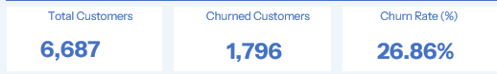

The kpi cards were created using shapes (rectangle: rounded corners) from the illustrations pane from the insert section on the tool bar after created one I duplicated to the amount I want by pressing down the CTRL button and dragging the shape until I have the amount I want and then I inserted a text box for title and the value and from the arrange section I aligned to top, distributed horizontally and grouped the kpi cards together.

For the values on the kpi cards I gave each kpi a specific name and I clicked on the text box and typed = and then I typed the name I gave to each cell and clicked ok.

**Analysis**

* **Churn by Demographics**

**Analysis Question:**

Which demographic segment (Senior, Other, or Under 30) accounts for the largest proportion of churned customers?

**Approach to answering the question:**

The aggregate table was highlighted and a pivot table was created with demographics in rows and a calculated field for churn rate% was created by dividing churned customers by total customers add put in values and then i set the number formatting to percentage and I created a pie chart by going to the pivot table analyze pane and clicking on pivot chart and selecting a pie chart.

**Insights:**

A significant portion of churn (39%) comes from the "Senior" demographic, followed by "Other" (25%) and "Under 30" (23%). This suggests that while churn is spread across segments, seniors represent a particularly vulnerable group that might require targeted retention efforts or specific product considerations.

**Analysis Question:**

Which specific age group has the highest churn rate despite its number of customers?

**Approach to answering the question:**

The aggregate table was highlighted, and a pivot table was created with age in rows and total customers and the calculated churn rate % in values set to sum and then I set the number formatting to percentage for churn rate, and I created a combo chart by going to the pivot table analyze pane and clicking on pivot chart and selecting a combo chart.

**Insights:**

While the 39-48 age group has the highest number of customers, the churn rate appears to peak in the older age groups, specifically 69-78 and 79-88 (as indicated by the rising blue line on the right). This suggests that older customers, even if a smaller absolute number, are disproportionately more likely to churn, indicating specific needs or challenges in serving this demographic.

**Analysis Question:**

Do customers with lower data consumption (Less than 5 GB) show a higher churn rate compared to those with higher consumption?

**Approach to answering the question:**

The aggregate table was highlighted, and a pivot table was created with unlimited data plan in columns, grouped consumption in rows and the calculated churned rate% in values set to sum and then i set the number formatting to percentage and I created a stacked column chart by going to the pivot table analyze pane and clicking on pivot chart and selecting a stacked column chart.

**Insights:**

Customers with "Less than 5 GB" data consumption appear to have a higher churn rate compared to those consuming more data. This suggests that low-usage customers might not perceive sufficient value from Databel's services or could be more price-sensitive, making them more prone to churn. Retention strategies might need to target this segment with more suitable plans or value propositions.

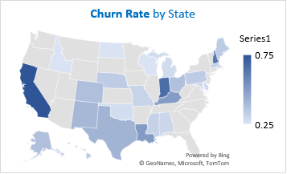

**Analysis Question:**

Which state on the map exhibits the highest churn rate, indicating a geographical area of concern?

**Approach to answering the question:**

The aggregate table was highlighted, and a pivot table was created with Intl plan in filters, state in rows and the calculated churned rate% in values set to sum and then i set the number formatting to percentage and I created a map visual by going to the pivot table analyze pane and clicking on pivot chart and selecting map.

**Insights:**

The map visually indicates that certain states (e.g., possibly California, as it appears darker, along with other potential darker spots in the Midwest or Northeast, though exact states aren't labeled for certainty) exhibit noticeably higher churn rates than others. This points to localized issues, perhaps due to specific regional competitor intensity, service quality, or market conditions, requiring a granular, state-level analysis and strategy.

**Analysis Question:**

Among customers churning due to competitors, what is the single most dominant reason (e.g., better devices, better offer)?

**Approach to answering the question:**

The customer table was highlighted, and a pivot table was created with churn category in filters, churn reason in rows and churn customers in values set to sum and I created a doughnut chart by going to the pivot table analyze pane and clicking on pivot chart and selecting a doughnut chart.

**Insights:**

Within the segment of customers who churned due to competitors, "Competitor had better devices" and "Competitor made better offer" are nearly equally dominant, each accounting for 37% and 36% respectively. This reinforces that Databel is lagging in both device quality/selection and the attractiveness of its offers compared to competitors, necessitating a dual focus on these areas.

**Analysis Question:**

What are the top five primary reasons customers are churning, and what percentage of churn do they represent collectively?

**Approach to answering the question:**

The customer’s table was highlighted, and a pivot table was created with churn reason in rows and churned customers in values set to sum and then i set the number formatting to percentage and I created a bar chart by going to the pivot table analyze pane and clicking on pivot chart and selecting a bar chart.

**Insights:**

"Competitor made better offer" and "Competitor had better devices" are the top two reasons for churn, collectively accounting for over 50% of reported reasons. This highlights that Databel's primary challenge in retaining customers lies in its competitive positioning, both in terms of pricing/offers and device quality, indicating an urgent need to re-evaluate these aspects.

**Visualization**



**INTERPRETATION OF RESULTS**

**Overall Churn Rate**

* Databel’s overall churn rate stands at 26.86%
* Over a quarter of customers are leaving the service.

**Churn by State**

Highest churn observed in California: 75%, Indiana: 66.67% and New Hampshire: 62.50% this Indicates geographic areas needing urgent retention efforts.

**Reasons for Churn**

* + 37% left for better devices from competitors
  + 37% left for better offers
  + 14% switched for more data
  + 12% left due to higher internet speeds elsewhere

Competition in pricing, data, and device quality is a major churn driver.

**Churn by Demographics**

* + Customers under 30 had the highest churn rates
  + Low data users (< 5GB) are more likely to churn

Younger, low-data users are a high-risk segment.

**Data Consumption & Churn**

* + Customers using 10GB or more show higher churn
  + Surprisingly, low data users (< 5GB) also churn frequently

Suggests dissatisfaction exists at both ends of the data usage spectrum.

**Competitor Influence**

* + Many customers churned due to better devices, pricing, and service offerings from competitors
* Indicates need to match or exceed competitor value propositions.

**Recommendation**

1. **Upgrade Device Offerings**

- Provide modern, high-quality devices to compete with other providers.

2**. Launch Competitive Pricing Plans**

- Introduce flexible and appealing pricing, especially for cost-sensitive users.

3. **Enhance Network Quality**

- Improve download speeds and data allowances to retain dissatisfied users.

4. **Deploy Targeted Retention Programs**

**Focus on:**

* + States with highest churn (e.g., California, Indiana)
  + Young users with loyalty programs
  + Low and high data users with customized plans and offers

**Conclusion**

This project highlights critical insights into why customers are leaving Databel.

* With an overall churn rate nearing 27%, urgent actions are required in specific regions and customer segments.
* By improving offerings, pricing, and service quality, Databel can significantly boost retention, customer satisfaction, and long-term profitability.